**Question No. 1**

Reproduce the following functionality using recursion. Just implement Sum() function. No need to write main function.

int Sum(int i)

{ int s=0;

while(i<=10) {

s = s + i; i++;

} return s;

}

**……………………………………………………………………………………………………………………………………………………**

**Question No. 3**

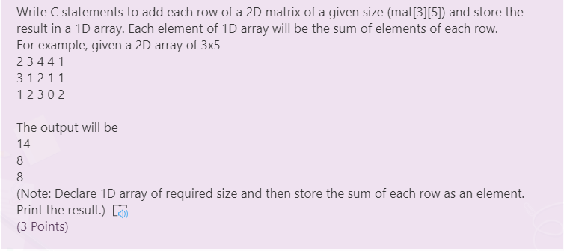

#include<stdio.h>

int main()

{

int i,j,mat[3][5] = {{0},{0}},arr[3],k,sum;

printf("Please enter entries\n");

for(i=0,k=0;i<3,k<3;i++,k++)

{

for(j=0;j<5;j++)

{

printf("Entry[%d][%d] = ",i,j);

scanf("%d",&mat[i][j]);

sum = sum + mat[i][j];

}

arr[k] = sum;

}

printf("Output of given entries in matrix form is: \n");

for(i=0;i<3;i++)

{

for(j=0;j<5;j++)

{

printf("%d\t",mat[i][j]);

}

printf("\n");

}

for(k = 0;k<3;k++)

{

printf("%d\n",arr[k]);

}

return 0;

}

**……………………………………………………………………………………………………………………………………………………**

**Question No. 4**

Read following program segment and write output for given segment (remove error(s) if any)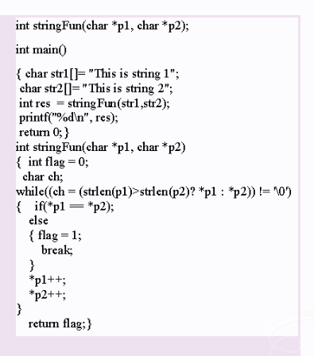

**……………………………………………………………………………………………………………………………………………………**

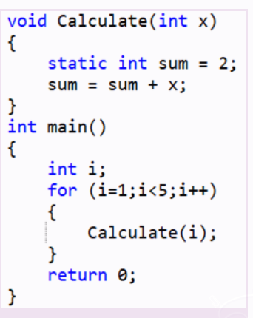**Question No. 5**

Consider the following code snippet. What will be the value of sum when Calculate () function after the final call?

#include<stdio.h>

void Calculate(int x)

{

static int sum = 2;

sum = sum + x;

printf("%d",sum);

}

int main()

{

int i;

for (i=1;i<5; i++)

{

Calculate(i);

}

return 0;

}

**……………………………………………………………………………………………………………………………………………………**

**Question No. 7**

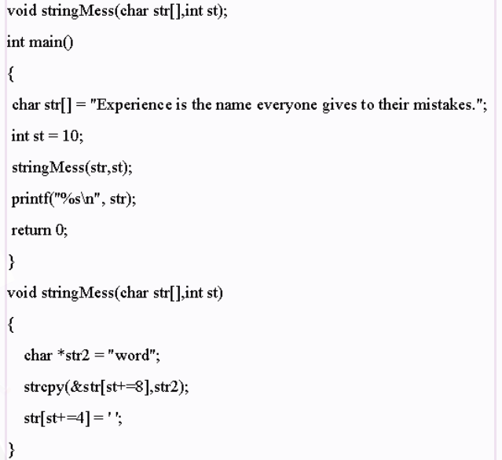

Read following program segment and write output for given segment (remove error(s) if any).

#include<stdio.h>

#include<string.h>

void stringMess(char str[], int st);

int main()

{

char str[] = "Experience is the name everyone gives to their mistakes.";

int st = 10;

stringMess(str,st);

printf("%s\n", str);

return 0;

}

void stringMess(char str[],int st)

{

char *str2 = "word";

strcpy(&str[st+=8],str2);

str[st+=4]='Name';

}

**……………………………………………………………………………………………………………………………………………………**

**Question No. 8**

Create a variable var of struct FOO type. Create a pointer of struct FOO type and point this pointer to the variable var. Use pointer to assign values to the data members and print the values using the pointer. Just write the statements would be performing the asking tasks.

Struct FOO

{ int x;

float y;

}

#include<stdio.h>

#include<string.h>

struct FOO

{

char name[100];

int marks;

};

int main()

{

struct FOO a,*aptr;

aptr=&a;

(*aptr).marks=15;

strcpy((*aptr).name,"Zohaib");

printf("Name of student is %s\n",(*aptr).name);

printf("Marks of student is %d\n",(*aptr).marks);

}

**……………………………………………………………………………………………………………………………………………………**

**Question No. 9**

Write C statements to tokenize the given string and store numbers in an integer array.

char str[50] = “1 2 3 4 5 6 7 8 9 10”;

(Note: Tokenize the string separated by space. Convert each string to an integer and then store it in 1D array. Print the result

The C library function int atoi(const char *str) converts the string argument str to an integer (type int).).

**……………………………………………………………………………………………………………………………………………………**

**Question No. 10**

Complete the code given below to find out the given array is palindrome or not. Note: Palindrome means a pattern which reads the same backward as forward.

#include<stdio.h>

#define SIZE 10

int main()

{ int X[] = {15, 34, 25, 1, 17, 11, 21, 35, -11,3};

int i=0,flag=1;

while() [//Part-1](https://part-1/)

{

if() [//Part](https://part/)2

{

[//Part](https://part/) 3

}

}

if() [//Part](https://part/)4

{

printf("Not Palindrome");

}

else

{ printf("Palindrome");

}

return 0;

}

#include<stdio.h>

int main()

{

int n,r,sum=0,temp;

printf("enter the number=");

Scanf("%d",&n);

temp=n;

while(n>0)

{

r=n%10;

sum=(sum*10)+r;

n=n/10;

}

if(temp==sum)

printf("palindrome number ");

else

printf("not palindrome");

return 0;

}

**……………………………………………………………………………………………………………………………………………………**

**Question No. 11**

Suppose we have an integer (4 Bytes) 2D array of 5×6 elements\Dimensions. The base address of the array is 1120. What will be the starting address of array [3][4]?

Suppose we have an integer (4 Bytes) 2D array of 5×6 elements\Dimensions. The base address of the array is 1120. What will be the starting address of array [3][4]? Justify your answer.

**……………………………………………………………………………………………………………………………………………………**

**Question No. 12**

Explain the difference between the statements on the left and the statements on the right For each group of statements, give the final value of x if the initial value of x is 1.

In above program are different from each other, you can see on left statement of program consist of

if..else if condition and on right statement of program is only two if condition.

Now we can see brief about this program

**On Left Program:**

Initial value of x=1 and when we execute the program if statement will be true (if(x>=0) for first condition

so that x=x+1 and ouput of -> x=2

so that else if part will be not executed.

Note:(instead of Else if there is minor change is else if )

**On Right Program:**

Initial value of x=1 and when we execute the program if statement will be true( if(x>=0 ) for first condition

so that x=x+1 and Output is x=2

and again it goes into another if condition it will be true ( if(x>=1 ) again.

so that x=x+2 that is first statement is will be x=2 so that x=2+2 i.e x=4

and output of second id condition is x=4.

in this program if is independent of each other but value of will be changed.

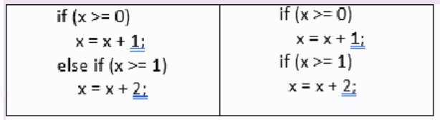

**……………………………………………………………………………………………………………………………………………………**

**Question No. 13**

For the given struct FOO create an array of 3 elements. Get values from the users and print them on the screen. Just write the statements would be performing the asking tasks.

struct FOO

{ char ch[20];

double var; };

#include<stdio.h>

struct FOO

{

char ch[20];

double var;

};

int main()

{

int i;

struct FOO arr[3] = {" ",0};

for(i = 0;i<3;i++)

{

printf("Enter your favorite food: ");

gets(arr[i].ch);

printf("Enter your favourite number: ");

scanf("%d",&arr[i].var);

printf("\n");

}

for(i = 0;i<3;i++)

{

printf("Your favourite food: %s",arr[i].ch);

printf("Your favourite number: %d",arr[i].var);

}

return 0;

}

**……………………………………………………………………………………………………………………………………………………**

**Question No. 14**

Consider the following code snippet. Identify the problem in code if any Yes/No? Justify your answer

#include<stdio.h>

int Table(int x)

{

int i;

for(i=1;i<=10; i++)

{

printf("%d * %d = %d\n", x,i,(x * i));

}

}

int main()

{

int n;

printf("Enter a number: ");

scanf("%d",&n);

Table(n);

return 0;

}

Reason: printf statement is outside the loop

* is used before x but pointers are not used

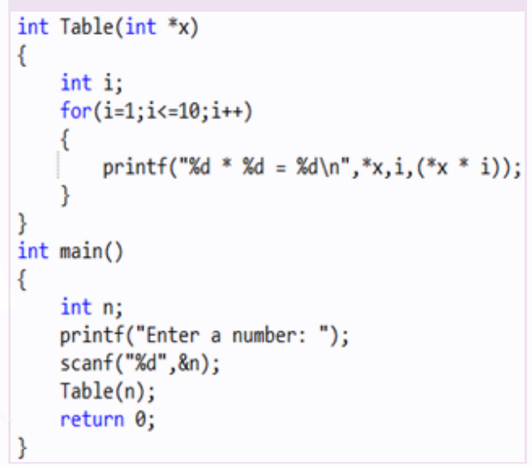

**……………………………………………………………………………………………………………………………………………………**

**Question No. 15**

What is the difference between the prefix and postfix forms of the ++ operator? if the value of x =9 then what will be effect of pre fix and post fix?

**……………………………………………………………………………………………………………………………………………………**

**Question No. 16**

Read following program segment and write output for given segment (remove error(s) if any).

#include<stdio.h>

int main(){

int arr[4][3]={{1,0,5},{2,4,9},{4,5,3}};

int *aptr,*bptr,*cptr;

aptr= &arr[0];

bptr= &arr[1];

cptr=aptr+2;

bptr=cptr-1;

printf("%d%d",*aptr,*bptr);

return 0;

}

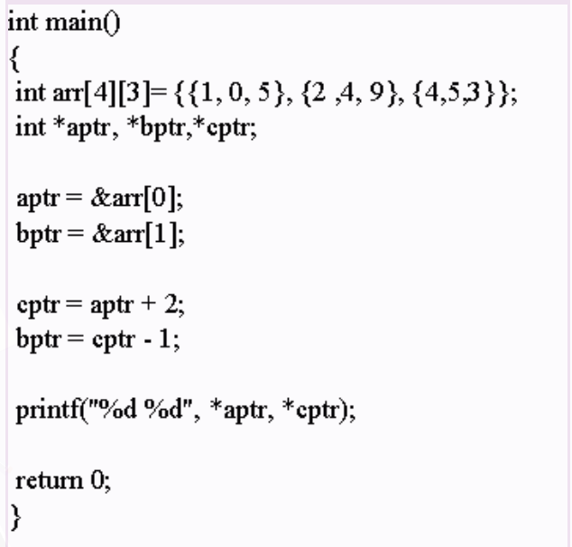

**……………………………………………………………………………………………………………………………………………………**

**Question No. 17**

Rewrite following program using switch statements.

int main() {

char color;

printf(“Enter R for Red, G for Green, B for Blue and Y for Yellow : ”);

scanf(“%c”,&color);

if(color==’R’ || color==’r’)

printf(“Red\n”);

else if(color==’G’ || color==’g’)

printf(“Green\n”);

else if(color==’B’ || color==’b’)

printf(“Blue\n”);

else if(color==’Y’ || color==’y’)

printf(“Yellow\n”);

else printf(“Invalid color!!!”);

return 0;

}

#include<stdio.h>

int main()

{

char color;

printf("Enter R for Red\nG for Green\nB for Blue\nY for Yellow:");

scanf("%c",&color);

switch(color)

{

case 'R':

{

printf("Red");

break;

}

case 'r':

{

printf("Red");

break;

}

case 'G':

{

printf("Green");

break;

}

case 'g':

{

printf("Green");

break;

}

case 'B':

{

printf("Blue");

break;

}

case 'b':

{

printf("Blue");

break;

}

case 'Y':

{

printf("Yellow");

break;

}

case 'y':

{

printf("Yellow");

break;

}

default:

{

printf("Invalid Color");

}

}

}

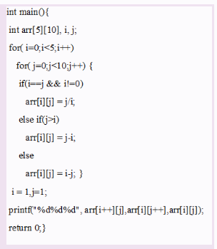**……………………………………………………………………………………………………………………………………………………**

**Question No. 18**

Read following program segment and write output for given segment (remove error(s) if any)

#include<stdio.h>

int main(){

int arr[5][10], i, j;

for(i=0;i<5;i++)

for(j=0;j<10;j++){

if(i==j&& i!=0)

arr[i][j] =j/i;

else if(j>i)

arr[i][j] =j-i;

else

arr[i][j] = i-j; }

i= 1; j=1;

printf("%d%d%d", arr[i++][i], arr[i++][j], arr[i][j++], arr[i][j]);

return 0;

}

Output: 111

**……………………………………………………………………………………………………………………………………………………**

**Question No. 18**

For the given struct FOO create a variable and initialize it with some values

struct FOO

{

int x;

float y;

}

#include<stdio.h>

struct FOO

{

int x;

float y;

};

int main()

{

int i;

struct FOO str = {12,23.33};

printf("%d\t%f",str.x,str.y);

return 0;

}

**……………………………………………………………………………………………………………………………………………………**

**Question No. 19**

Write a single printf statement that prints “Positive Number” if the value of integer variable is greater than or equal to zero, “Negative Number”, otherwise

#include<stdio.h>

int main()

{

int n = 5;

printf("%s", n>=0 ? "Positive" : "Negative");

return 0;

}

**OR**

#include<stdio.h>

int main()

{

int n ;

printf("Enter Number");

scanf("%d",&n);

printf("%s", n>=0 ? "Positive" : "Negative");

return 0;

}

**……………………………………………………………………………………………………………………………………………………**

**Question No. 20**

Give a new name to the following struct FOO . Create a variable using new name of struct FOO type. Just write the statements would be performing the asking tasks.

Struct FOO

{ int x;

float y;

}

#include<stdio.h>

#include<string.h>

struct FOO

{

char name[100];

int marks;

};

int main()

{

struct FOO a;

}

**……………………………………………………………………………………………………………………………………………………**

**Question No. 22**

Differentiate between sequential and repetition structures and give an example of each structure

**……………………………………………………………………………………………………………………………………………………**

**Question No. 23**

Consider the following code snippet. Identify the error in code if any Yes/No? Justify your answer

#include<stdio.h>

int factorial(int n);

int main(){

int x;

factorial(x);

}

factorial(int n){

int i;

int fact=1;

for(i=1;i<=n;i++){

fact=fact*1;

}

return fact;

}

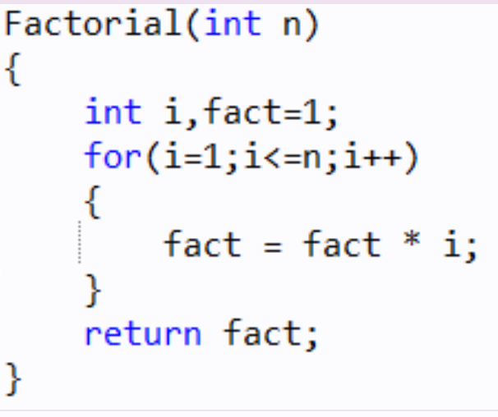

**……………………………………………………………………………………………………………………………………………………**

**Question No. 24**

Consider an array X with elements 15, 34, 25, 1, 17, 11, 21, 35, -11,3. We want to apply bubble sort algorithm to sort the array in ascending order. What will be the arrangement of values after completion of 3rd iteration of outer loop?

**OUTPUT:** 1 15 11 17 21 -11 3 25 34 35

#include<stdio.h>

#define MAX 10

void print(int x[],int n)

{

int i;

for(i=0;i<n;i++)

printf("%d\t",x[i]);

printf("\n");

}

void sort(int x[],int n)

{int pass,i,hold;

for(pass=0;pass<3;pass++){

for(i=0;i<n-1;i++){

if(x[i]>x[i+1])

{

hold = x[i];

x[i] = x[i+1];

x[i+1] = hold;

}

}

}

}

int main()

{int i,pass,hold,a[]={15,34,25,1,17,11,21,35,-11,3};

print(a,MAX);

sort(a,MAX);

print(a,MAX);

return 0;

}

**……………………………………………………………………………………………………………………………………………………**

**Question No. 25**

Complete the code given below to reverse the elements of the array. #include<stdio.h>

#define SIZE 10

int main() {

int X[] = {15, 34, 25, 1, 17, 11, 21, 35, -11,3};

int i=0, temp;

for(i=0;i<SIZE/2;i++)

{

[//Write](https://write/) your code here

}

return 0;

}

#include<stdio.h>

#define SIZE 10

int main() {

int X[] = {15, 34, 25, 1, 17, 11, 21, 35, -11,3};

int i, temp;

int j=SIZE-1;

for(i=0;i< SIZE/2;i++)

{

//Write your code here

temp=X[i];

X[i]=X[j];

X[j]=temp;

j--;

}

for(i=0;i<SIZE;i++){

printf("%d\t",X[i]);

}

return 0;

}

**……………………………………………………………………………………………………………………………………………………**

**Question No. 26**

Read following program segment and write output for given segment (remove error(s) if any).

#include<stdio.h>

#include<string.h>

struct FOO

{int a;

double b;};

void fun(struct FOO f){

f.a += 20;

f.b += 30;}

int main(){

struct FOO var;

var.a=1;

var.b=2.0;

fun(var);

printf ("a = %d\nb=%.2f\n",var.a,var.b);

return 0; }

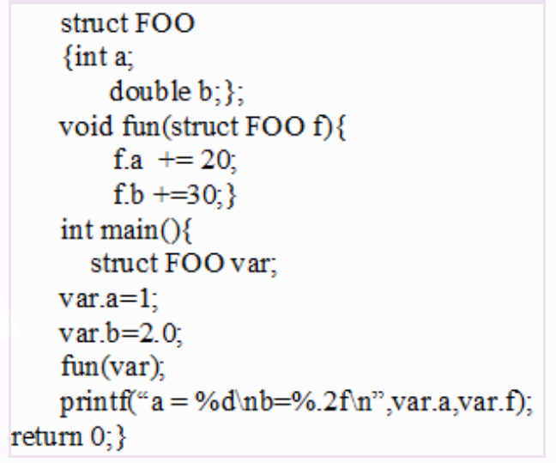

**……………………………………………………………………………………………………………………………………………………**

**Question No. 27**

Write down four data type names and mention size of each data type?

Int 4byte

Char 1byte

Float 4byte

Doublefloat 8byte

………………………………………………………………………………………………………………………………………………………..…